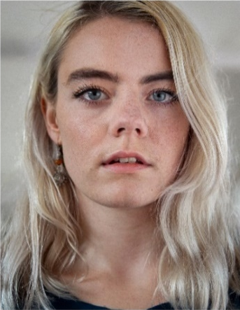
RACHEL LAIRD
07772474840 | rachellairddance@gmail.com
Rachel is a passionate and playful performer from Scotland. She utilises her focus, articulation, and voice work to make her movement expressive and full bodied. Rachel is interested in communication and how that plays a part in society. Whether that is through movement or language. Using improvisation, physical theatre, poetry, and contact work to try and relate and portray her experiences to others.
PROFESSIONAL EXPERIENCE 2022 – 2018 (In order of relevance)
Peut-Être Theatre – SHHH..Bang! China Tour ‘19 – ‘20 + Tidy Up (UK) ‘20
Garsington Opera – Eugene Onegin Tchaikovsky. Garsington Opera Wormsley Estate ‘21
English National Opera – Orphée Phillip Glass. English National Opera London Coliseum ‘19
Sliding Doors Collective (Co-Founder, Choreographer and Performer) - Penthouse Hickies Resolution Festival ‘20, DanceLive Citymoves ’20, Dumfries & Galloway Arts Festival ’20, Heads Up Ed Fringe’19 + Rising Tides London.
Next Door Dance – The Beautiful Game South England Tour ‘22.
A Truefitt Collective – Magical Minds North London Schools Tour ’21. We Never Arrive R&D London ’19.
Ròisìn O’Brien Dance (Performer and Rehearsal Director) – A Falling Ballet Hidden Door Festival Edinburgh ’21, Scratch Night SummerHall, Pianodrome Lunchtime sessions, Edinburgh Fringe’19.
Jamie Neale – Here But Know Where Performer, Fashion Dance Film ‘20
Amber Kim – REPURPOSE Exhibition (Choreographer and Performer) Fashion Show, London.
The Natashas Project -On Demand + Natashas London tour ‘19. R&D Children’s show ‘22
FOUND DANCE – Site Specific performances at Our City Dances ‘19 South East Dance + Farley’s Surrealist Picnic ‘21
Van Huynh Company - Under This Weight. Dance Bridges Festival. Kolkata, India.
The Yonis - #Girlswhospittogetherstaytogether Fringe’18, Dance Base Edinburgh + London
Private Agenda – Neo Nostalgia (Music Video Dancer and Choreographer ‘21)
Hilang Child – Good To Be Young (Music Video ‘20)
Cuckoolander - Mercury (Music Video ‘18)
PERFORMANCE EXPERIENCE (other)
Hagit Yakira – GO, Scottish Tour
Theo Clinkard - Alert to the voices of others, Scottish Tour.
Theo TJ Lowe – He–Sha Commissioned work performed at Laban London
Martha Graham – Restaging of Panorama by Jacqueline Bulnes performed at Laban London
Heidi Rustgaard (H2 Dance) – Groups and Landscapes commissioned work at Laban + toured across London
Yael Flexer - Vortex & Re|Place (Or the thing I miss most), NYDC Scotland toured to UK, Ireland, and India.
BalletLorent – Rapunzel, Macrobert Arts Centre Stirling Community Cast
Matthew Robinson – Office, Scottish Tour.
Gavin Coward -The art of letting go Directed by Liv Lorent. Scottish Tour
Thomas Small - BBC Radio 2 Shakespeare Shuffle, BBC Radio 2 Artists in Residence Dance Film on the London Eye.
Marc Brew – EQ Dance! Collaborative project with Edinburgh String Quartet, performed in Edinburgh
TRAINING
Copenhagen Contemporary Dance School Post Graduate Diploma Contemporary Dance
Trinity Laban Conservatoire of Music and Dance BA (HONS) Degree Contemporary Dance
Scottish School of Contemporary Dance HND Contemporary Dance

PLACEMENT
Rob Heaslip Dance FREAGRA | A Blurred Expanse
BalletLorent R&D Rumpelstiltskin and assisting family workshops at Sadler’s Wells
OTHER SKILLS AND/OR INTERESTS - Musical theatre background, improvisation, contact improvisation, physical theatre, hand to hand acrobatics, yoga, film, acting, writing, poetry, and pottery

